Student’s name | …………………………………………………….…… | Grade | 5
Subject | Computer | Week No. | 3
Lesson Title | Computers Around Us | Unit
Worksheet No. ( 3 ) (Answer)

write the correct name of each part.
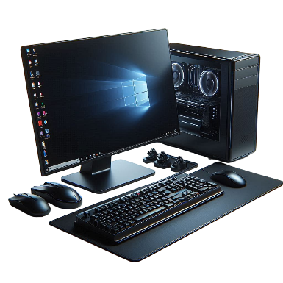
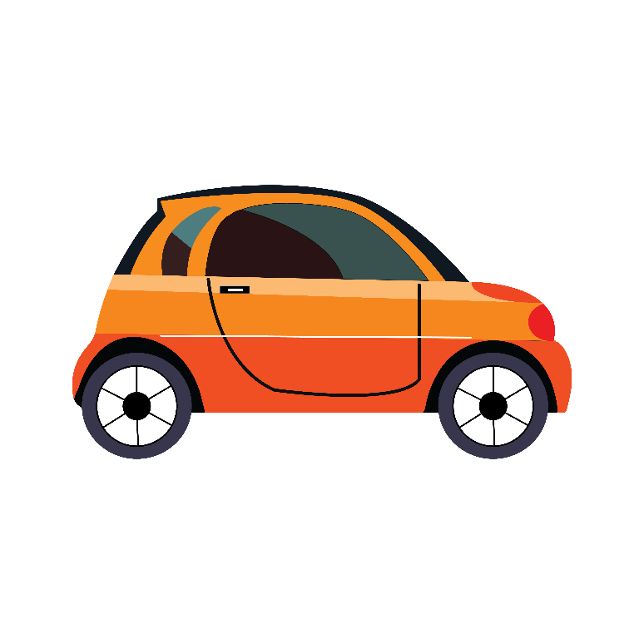
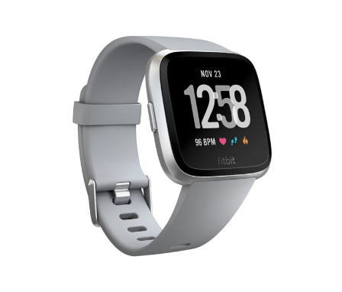
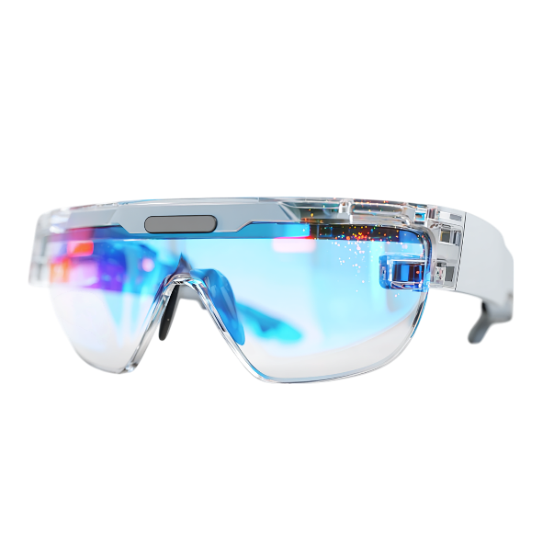
PC or Computer

Smart Glasses

Smart Car

Smartwatch

Good Luck

Smartwatch
Smart Glasses
PC or Computer
Smart Car

